SRS section 3.2 TEMPLATE:
(NOTE: THIS IS JUST A TEMPLATE, you are to use as reference then INCLUDE this in Section 3.2 of the SRS)

Using the SE Team Project with Line Numbers.doc Requirements, through TEXTUAL ANALYSIS please extract the functional and non-functional Requirements.

These requirements must be expressed as a set of declarative “shall” statements.

The list of functional requirements shall be divided into sections that group related requirements into cohesive sets. These sections might include “User Interface”, “Payment”, “Orders” etc. You need to add to the Line Number that it refers to.

Each requirement shall be given a unique ID number for traceability.

Each functional requirement shall be assigned a priority M, S, C or W according to the
MoSCoW criteria listed in Table 1:

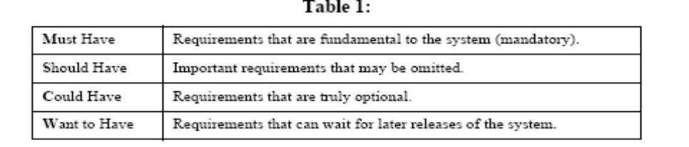

The list of non-functional requirements shall be divided into sections that group related requirements into cohesive sets. Here is a list of commonly used sections:

• Capacity
• Availability
• Performance
• Compliance to Standards
• Security

Listed below is a template for listing these requirements.

TABLE 1: LABELED Requirements
ID | Detail | Type | Priority | Line Numbers | Use Case  Name
R1 | The TEAM?OPTS shall display a list of queries available to CMs | Queries  Functional | MustHave | 145 - 173 | UC1
……….
R26 | The TEAM?OPTS shall authenticate CMs. | Authentication  Non Functional | MustHave | 223 - 227 | UC7

223 For Company Managers: If a user identifies himself or herself as a manager,
224 they are required to provide their employee id for authentication. On pressing
225 continue, if the employee id exists a Manager Access window pops up listing all
226 the queries that managers can access. If not an error message pops up on the screen 227 indicating invalid employee id.

NOTE: Every time you have extracted your R ID from SE Team Project with Line Numbers.doc requirements (it is possible that you modify the original document, thus make sure that the line numbers match), highlight that text corresponding to the line numbers from the table above as shown below:

223 For Company Managers: If a user identifies himself or herself as a manager,
224 they are required to provide their employee id for authentication. On pressing
225 continue, if the employee id exists a Manager Access window pops up listing all
226 the queries that managers can access. If not an error message pops up on the screen 227 indicating invalid employee id.

